**Centre Name: ACE-HCMC-2-FPT.**

**Address: 590 Cach Mang Thang 8, District 3, Ho Chi Minh City, Viet Nam.**

**ONLINESHOP4DVDS**

**Design Document**

|  |  |  |
| --- | --- | --- |
| **Supervisor:** | Mr. Le Tuan Xuyen | |
| **Semester:** | 3 | |
| **Batch No:** | T1.2303.M0 | |
| **Group No:** | 3 | |
| **Order:** | **Full name** | **Roll No.** |
| 1. | Bùi Trần Nguyên Hưng | Student1462831 |
| 2. | Trương Nguyễn Quang Huy | Student1468180 |
| 3. | Nguyễn Anh Khoa | Student1459131 |
| 4. | Vũ Minh Tuấn | Student1459120 |
| 5. | Bùi Thị Nhung | Student1459130 |

* **This is to certify that**

**Mr.** Bùi Trần Nguyên Hưng

**Mr.** Trương Nguyễn Quang Huy

**Mr.** Nguyễn Anh Khoa

**Mr.** Vũ Minh Tuấn

**Ms.** Bùi Thị Nhung

**have successfully designed & developed:**

eProject: ONLINESHOP4DVDS

* **Submitted by:**

Mr. Le Tuan Xuyen

**Date of issue:** 7/12/2024

# Landing page

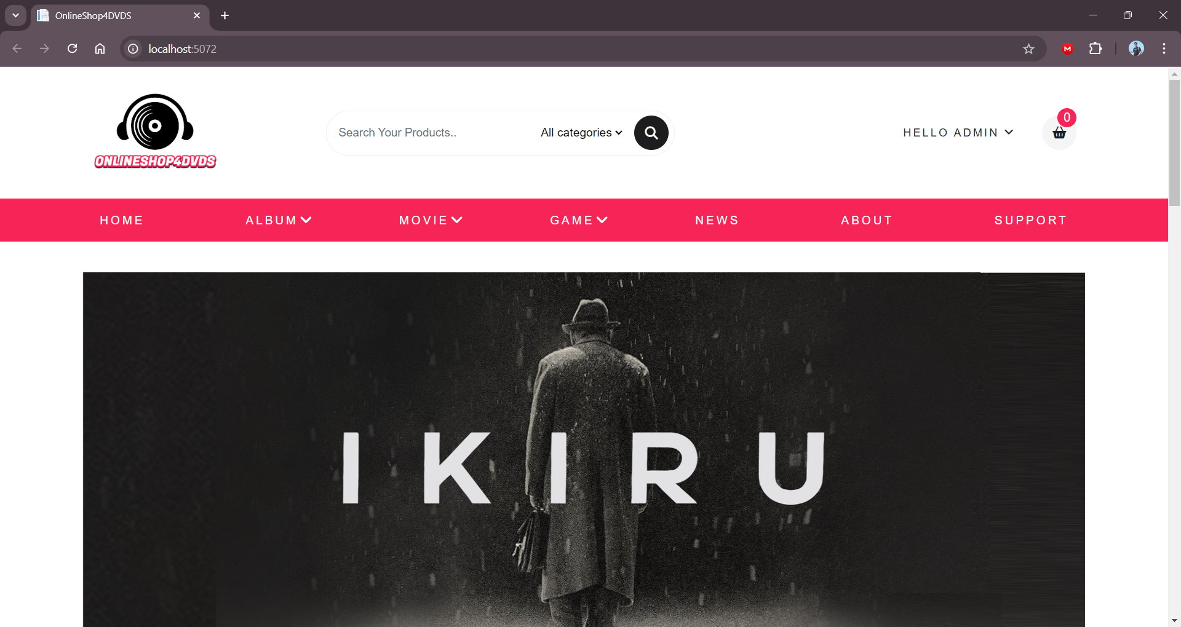

With a navigation bar you change view many showing pictures of this page

Especially you can login and edit your profile in the Account Manager shown in left corner: 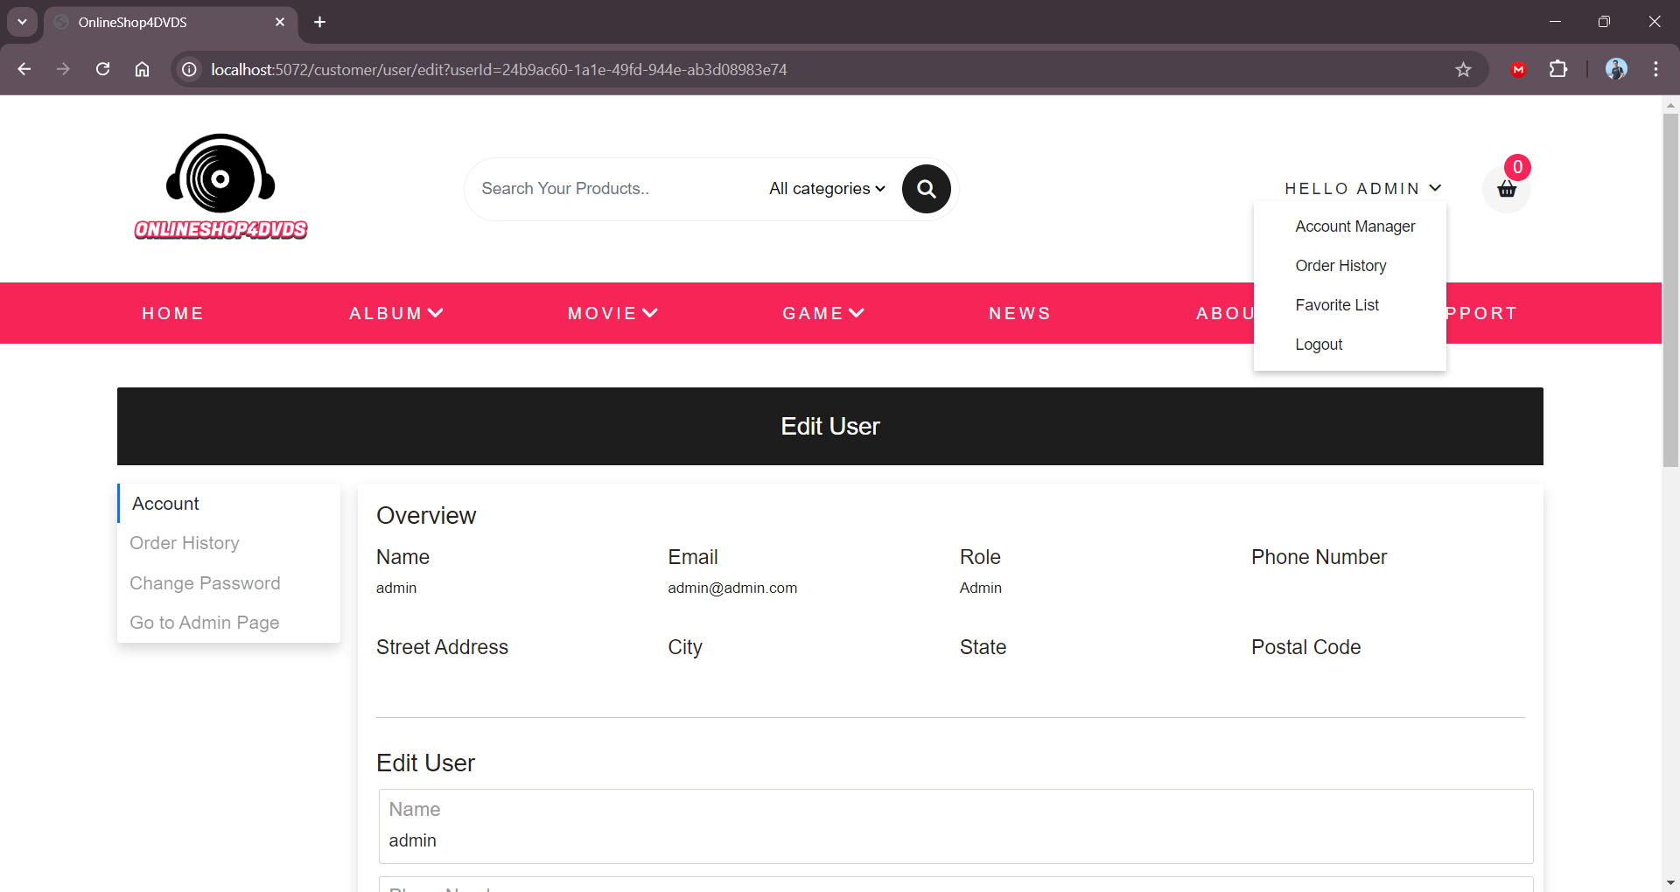

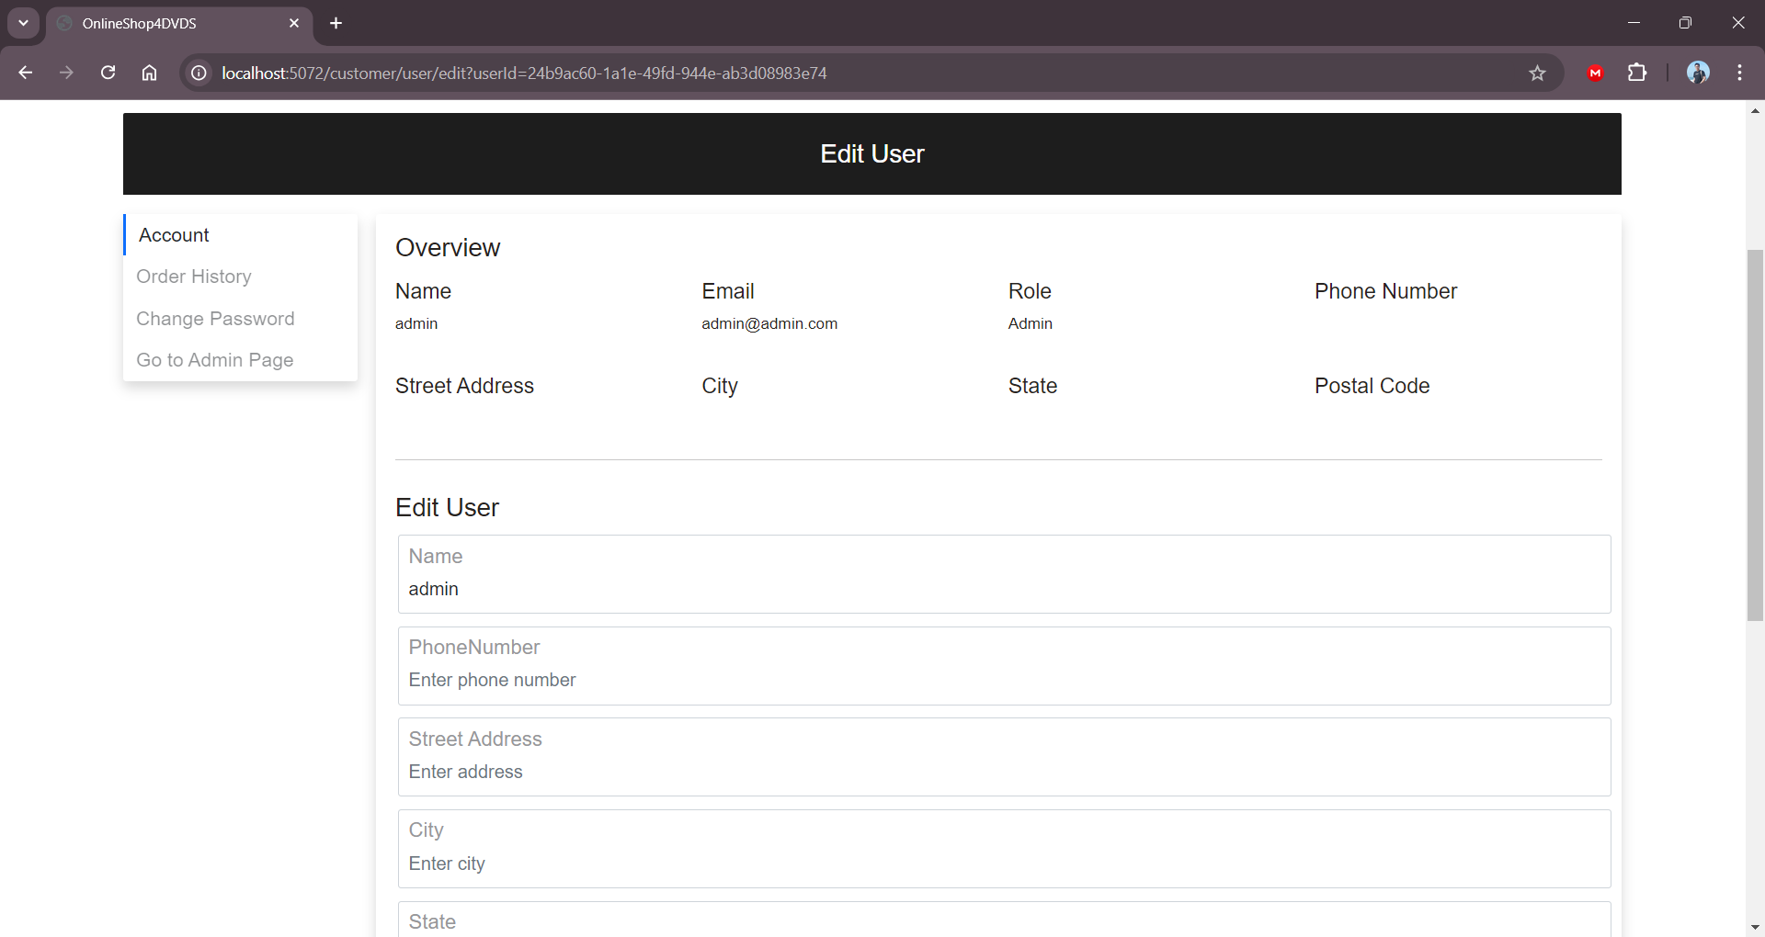

# Login, register page

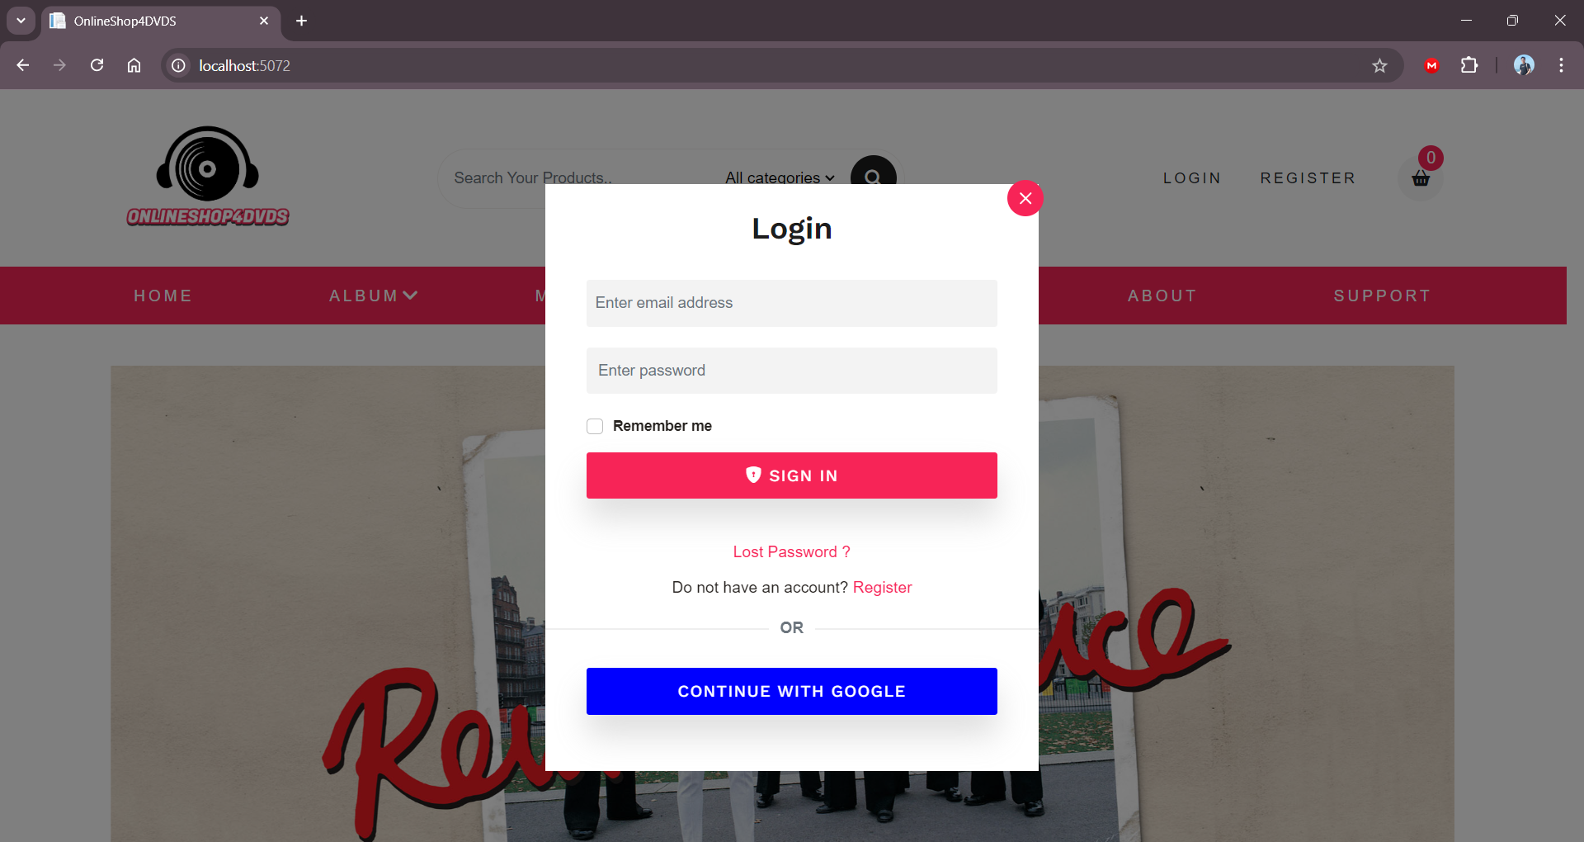 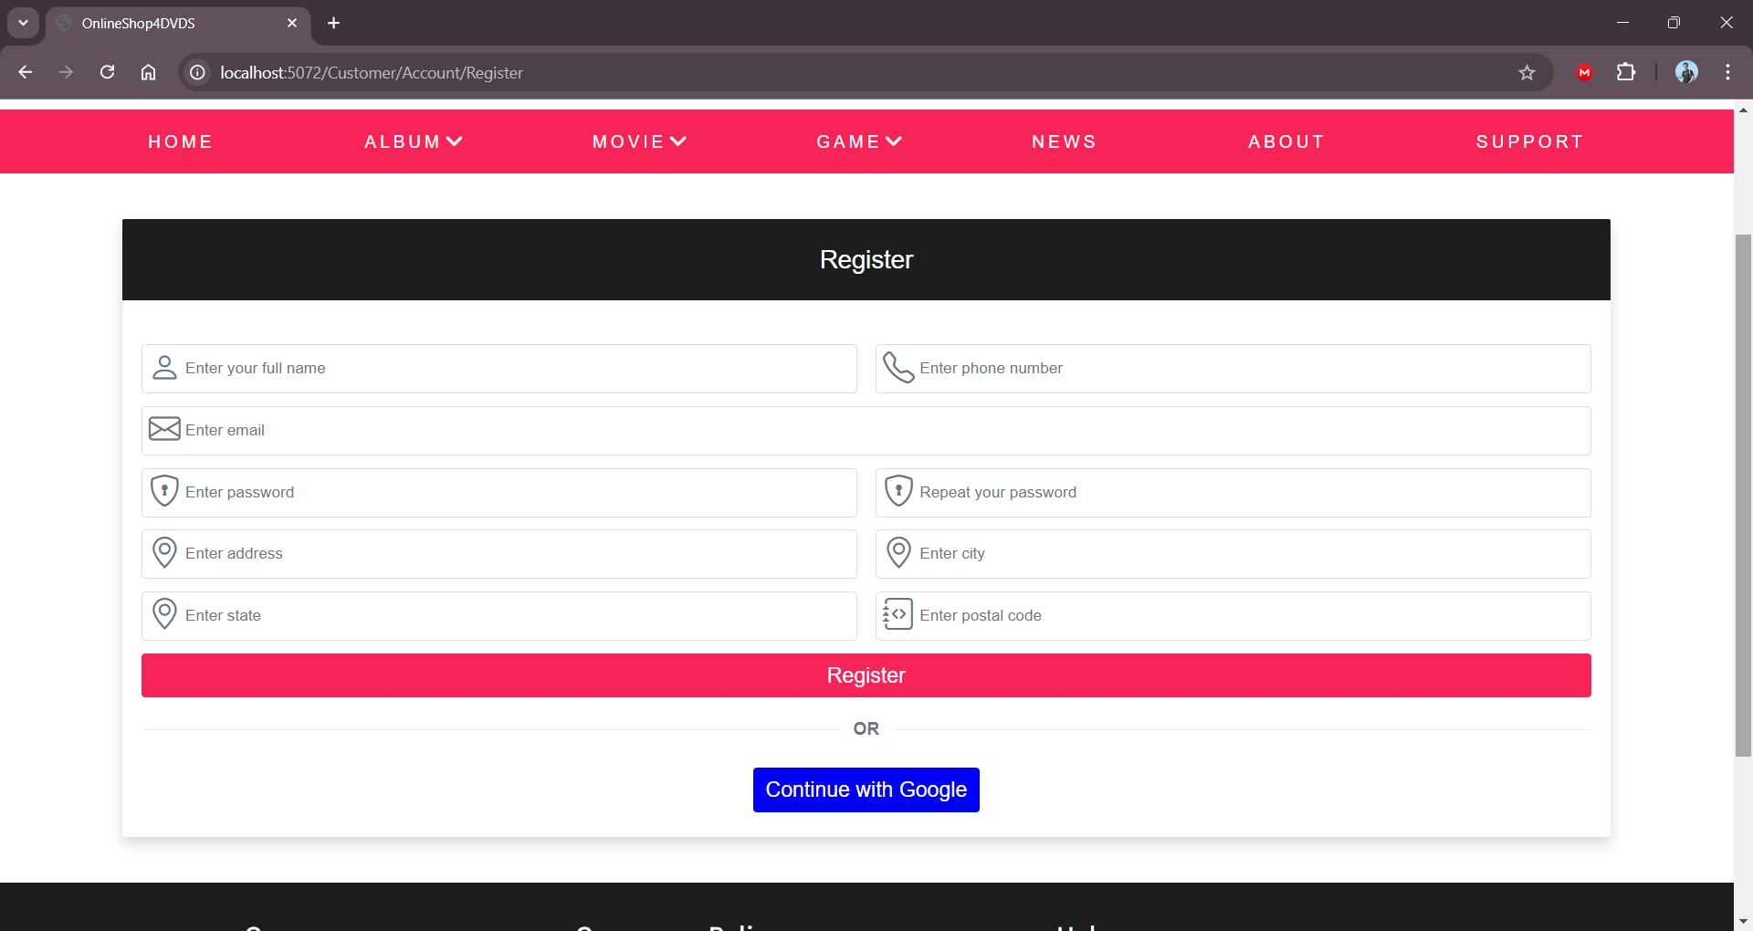

Register easily with email if you do not have an account yet. And login

# Dashboard and homepage

Login first.

First page is the dashboard, you can see chart and overall number of some stats . By clicking on the chart and buttons you can see detail of those stats, or see more to display all of them in list.

Additionally, you can see the list of all managers on the right side of the dashboard.

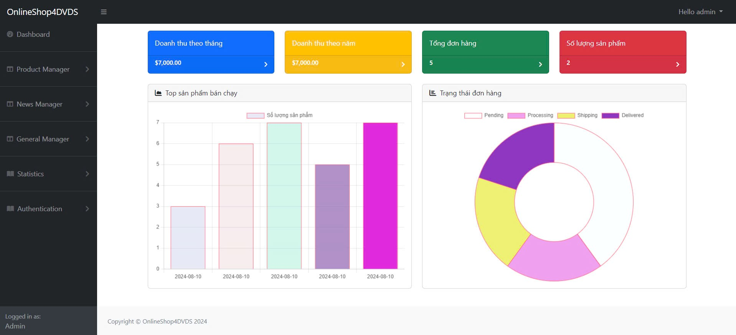

Don’t forget go to detail to see clearly about the product you’re interested in and reviews. 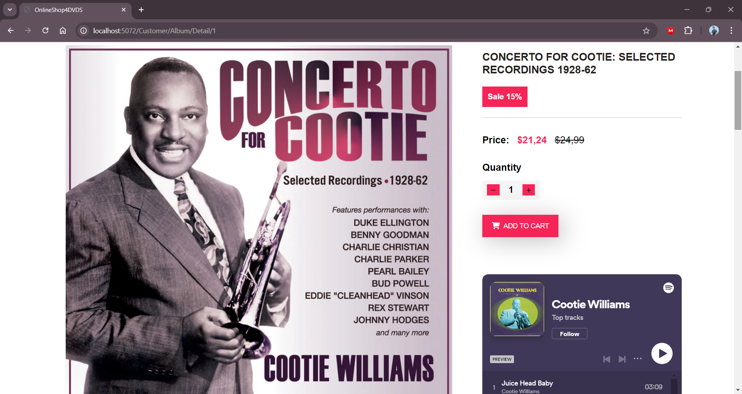

You can leave a review here to share your thought on product you bought.

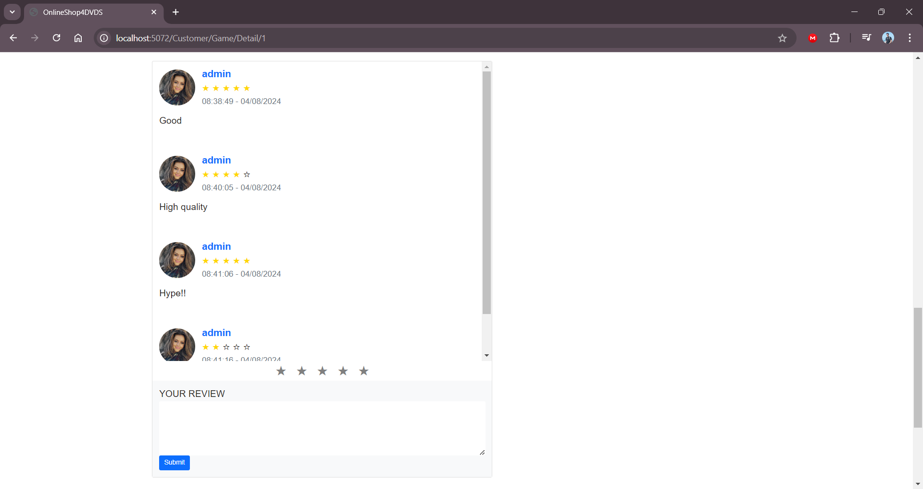

CRUD all product, artist, news, category, ads and promotion as admin

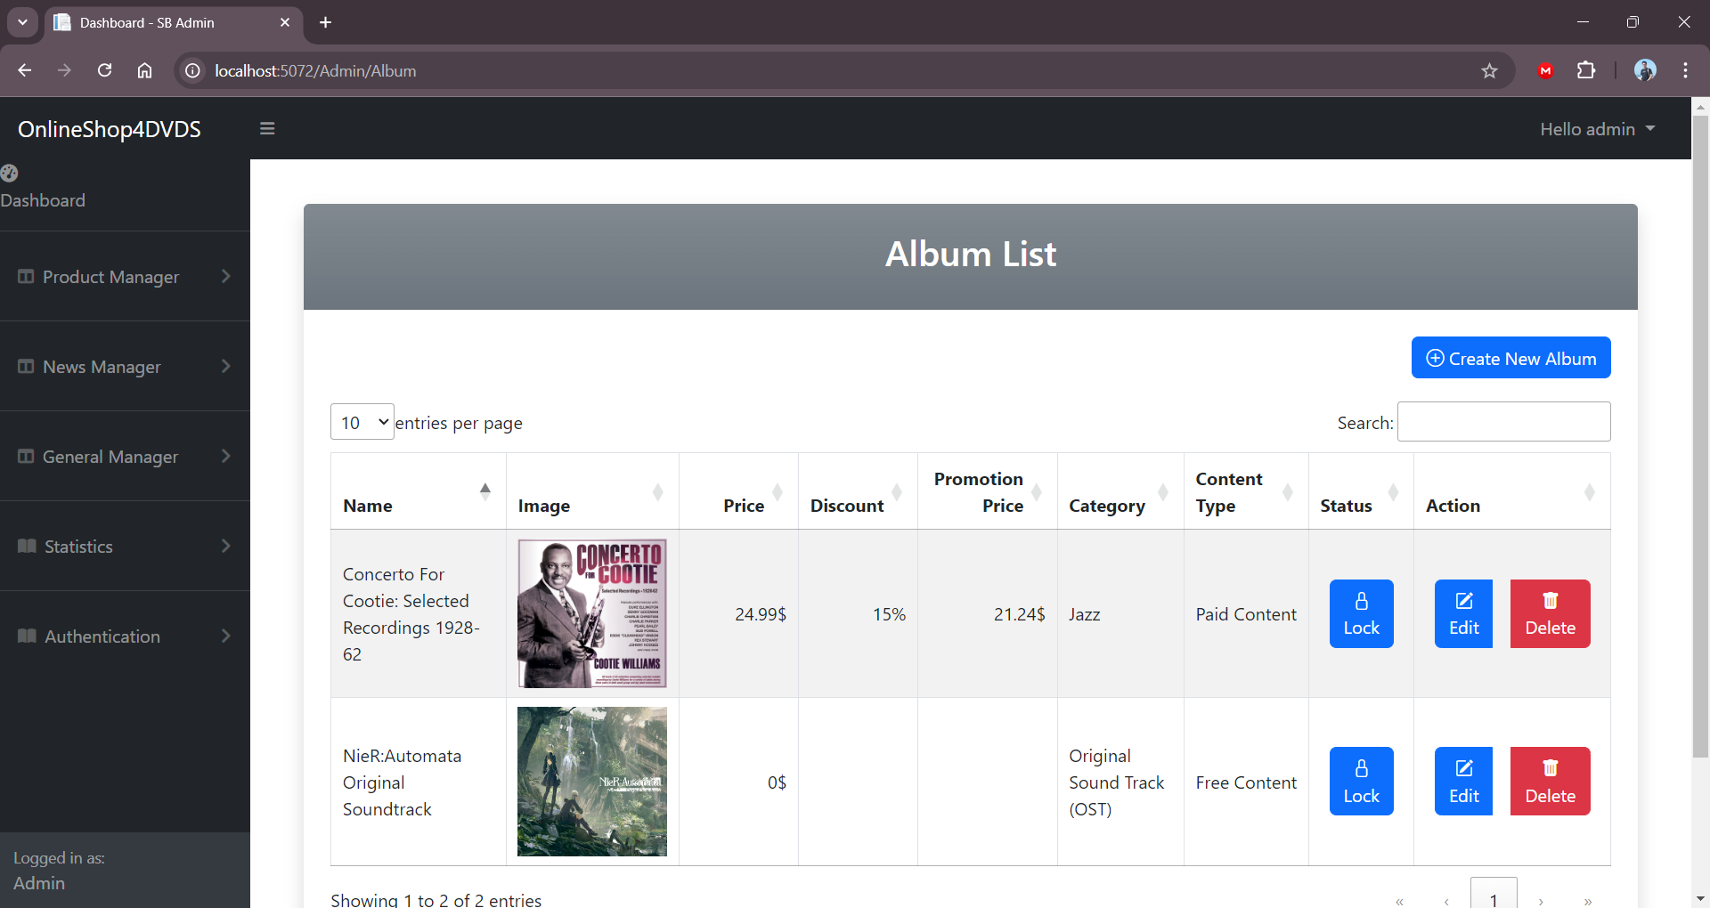

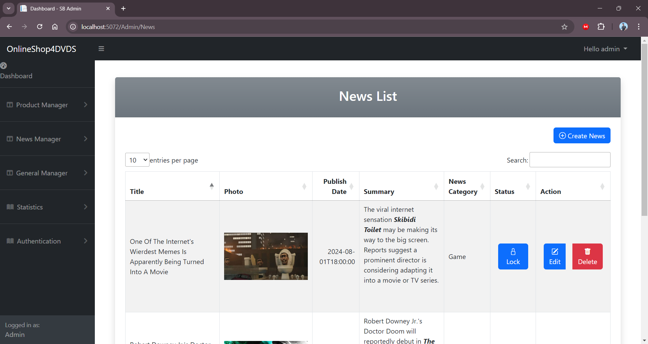

Admin can navigate all the CRUD on the left menu side to edit, delete as they want.

This is how a product list can be viewed as admin.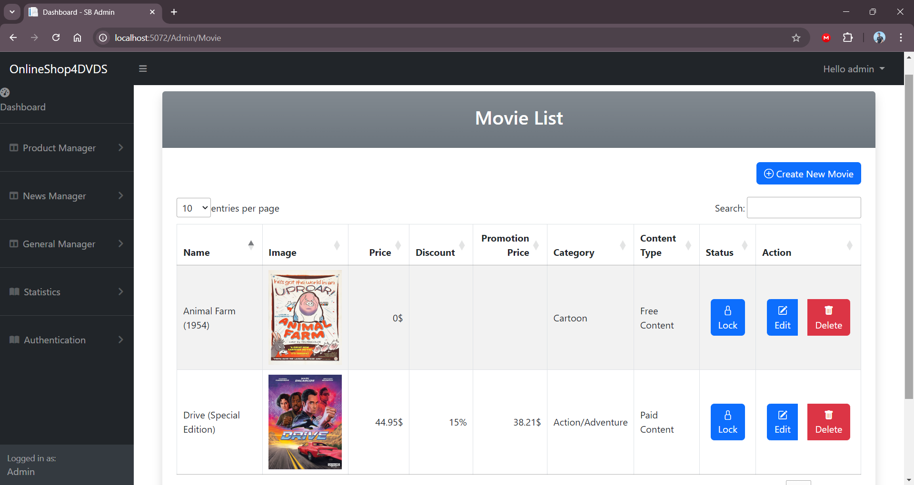

Click in your avatar image in top right page, you can view your profile and update it.

Admin can view all the user.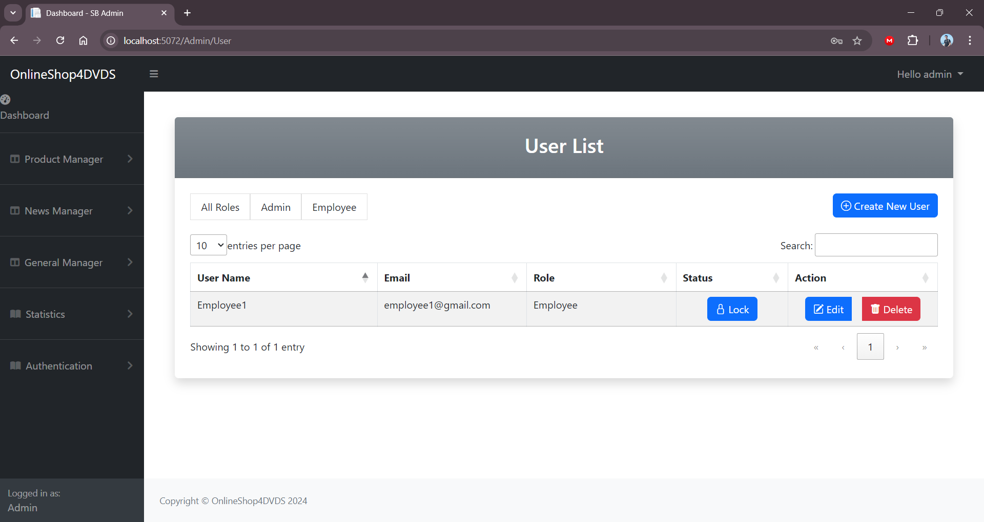

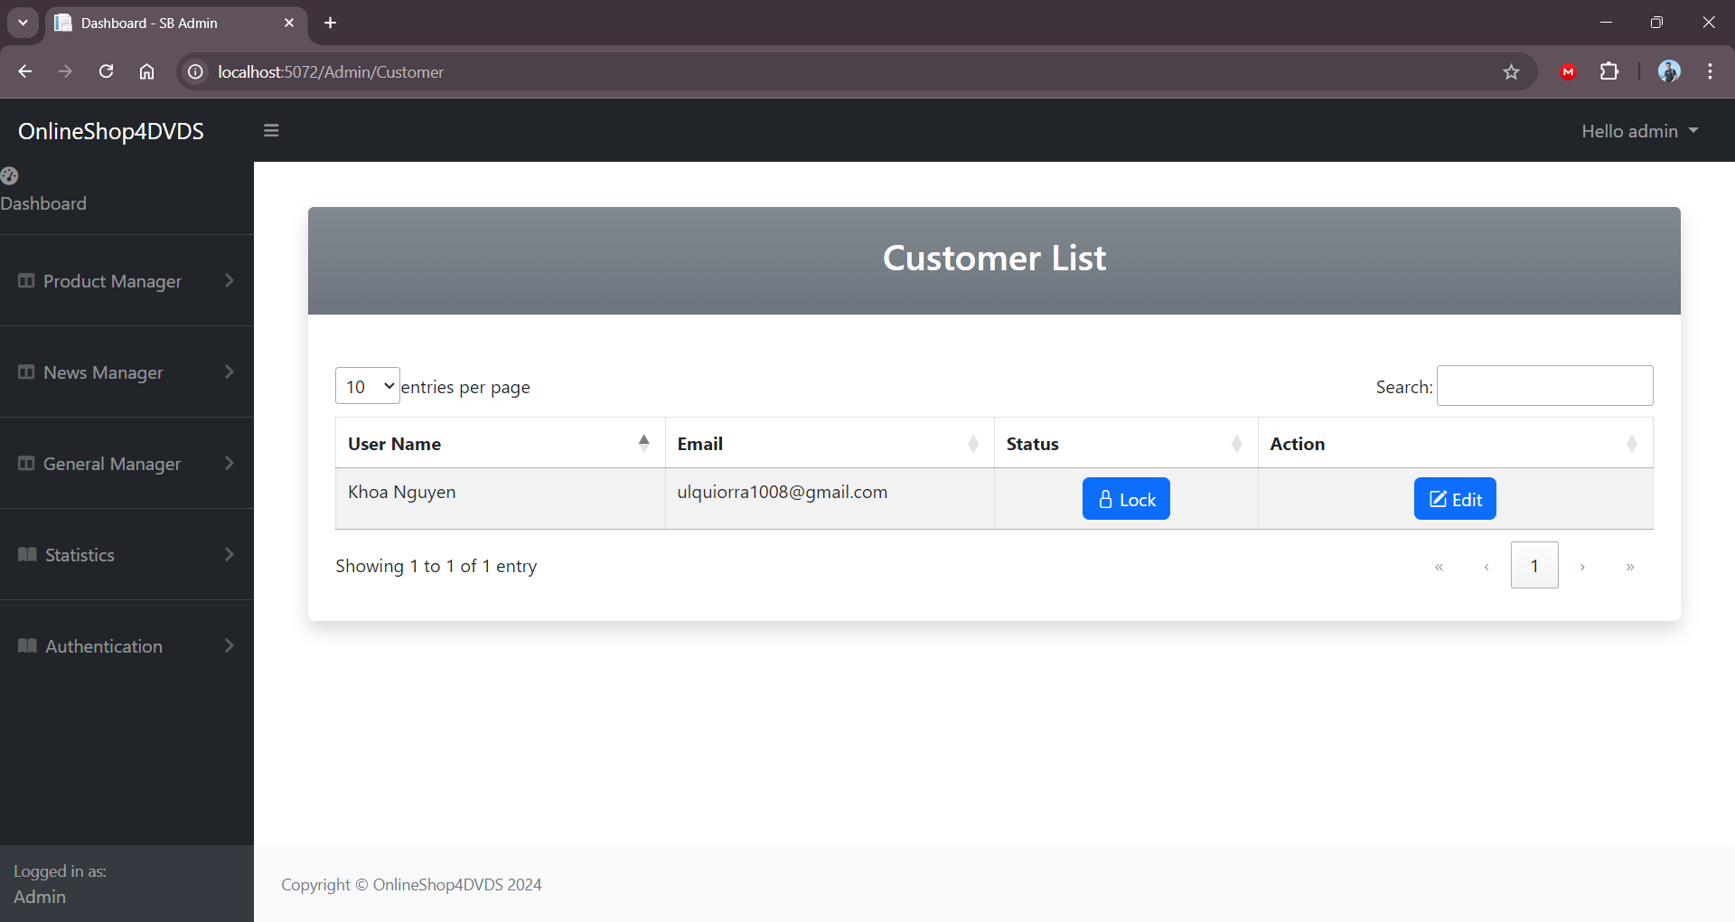

Admin can also edit user information as needed or requested by customers.

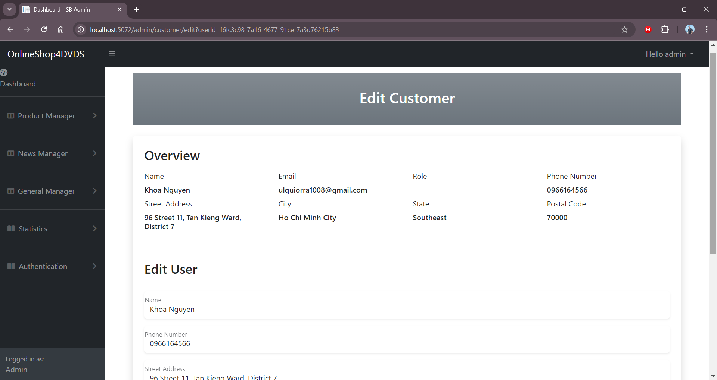

Send us the feed back in Feedback via the Support button on the main menu

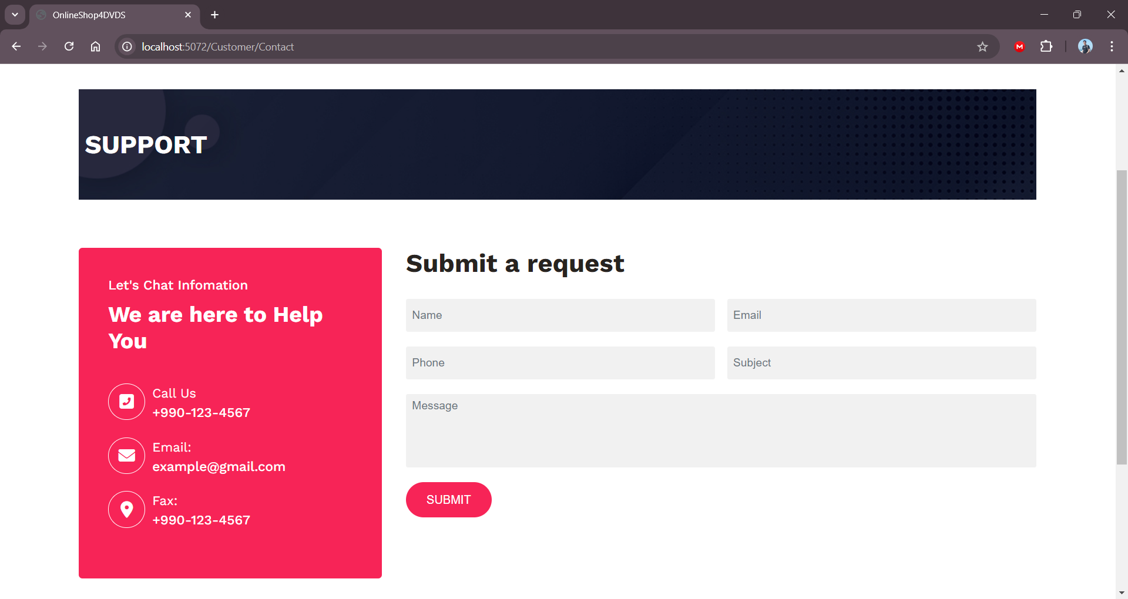

Reset or change you password on menu > Account Manager > Change Password. Enter your previous password and new password that you want to change to.

